**Azure PowerShell Command for Web App**

In this article we will go step by step to Create, Remove, name reserved or not and Run the Web App using Azure PowerShell on Microsoft Azure  
  
**Prerequisites**

* Microsoft Azure Subscription (MSDN subscribers or [sign up for one month free trial](https://azure.microsoft.com/en-us/free/))
* [Windows PowerShell](https://en.wikipedia.org/wiki/Windows_PowerShell). To Download PowerShell [Click here](http://go.microsoft.com/?linkid=9811175&clcid=0x409)

**You will learn**

* About PowerShell Tool
* How to Create Web App using PowerShell
* How to Remove Web App using PowerShell
* Check Web App Name reserved or not
* Run Web App using command

**Step 1:**Install PowerShell on System.  
  
**Step 2:** After installation, Open search box and search for **Windows PowerShell**  
  
[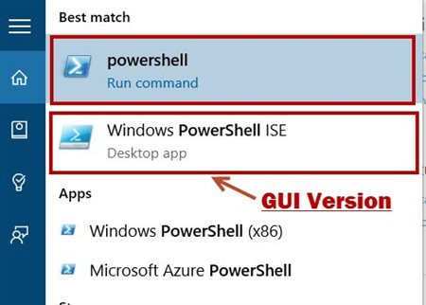](http://social.technet.microsoft.com/wiki/cfs-file.ashx/__key/communityserver-wikis-components-files/00-00-00-00-05/3716.AzurePSWP01.jpg)  
  
There are two type of Windows PowerShell is available:

* **Windows PowerShell** – Command Line
* **Windows PowerShell** – Execute the PowerShell script such as .ps file. GUI version of Windows PowerShell.

Windows PowerShell ISE version  
  
[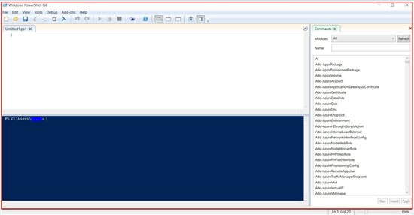](http://social.technet.microsoft.com/wiki/cfs-file.ashx/__key/communityserver-wikis-components-files/00-00-00-00-05/1307.AzurePSWP02.jpg)  
 **Step 3:** Add Azure Subscription with PowerShell

*Add-AzureAccount*

[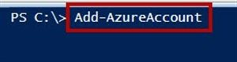](http://social.technet.microsoft.com/wiki/cfs-file.ashx/__key/communityserver-wikis-components-files/00-00-00-00-05/0724.AzurePSWP03.jpg)  
  
[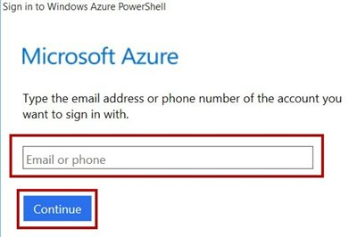](http://social.technet.microsoft.com/wiki/cfs-file.ashx/__key/communityserver-wikis-components-files/00-00-00-00-05/1817.AzurePSWP04.jpg)  
  
Enter your Azure Subscription credentials.

**Note: if Azure commands not working or any warning please type below command first.**

**Install-Module Azure**

[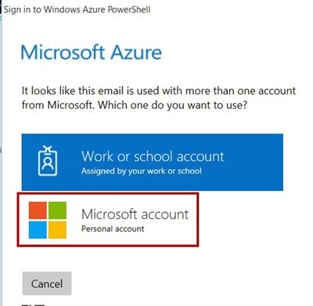](http://social.technet.microsoft.com/wiki/cfs-file.ashx/__key/communityserver-wikis-components-files/00-00-00-00-05/3757.AzurePSWP05.jpg)  
  
  
Few more command for Azure account details

*Get-AzureAccount*

List all the associate Azure Subscription with Id, Type, Subscriptions and Tenants  
  
[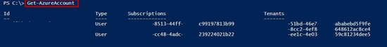](http://social.technet.microsoft.com/wiki/cfs-file.ashx/__key/communityserver-wikis-components-files/00-00-00-00-05/1680.AzurePSWP06.jpg)

*Get-AzureSubscription*

List all the associate Azure Subscription with all details such as SubscriptionId, SubscriptionName, Account, etc.  
  
[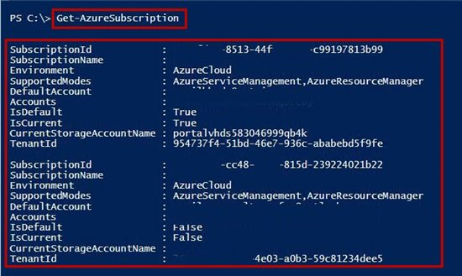](http://social.technet.microsoft.com/wiki/cfs-file.ashx/__key/communityserver-wikis-components-files/00-00-00-00-05/8306.AzurePSWP07.jpg)  
  
if there is only one subscription associate so no problem but if more than one azure account is there so we need to set default azure account for all operations.

*Select-AzureSubscription –SubscriptionId “paste-subscription-id-here”*

[http://social.technet.microsoft.com/wiki/resized-image.ashx/__size/550x0/__key/communityserver-wikis-components-files/00-00-00-00-05/1854.AzurePSWP08.jpg](http://social.technet.microsoft.com/wiki/cfs-file.ashx/__key/communityserver-wikis-components-files/00-00-00-00-05/1854.AzurePSWP08.jpg)  
  
Check for default subscription

*Get-AzureSubscription -Default*

[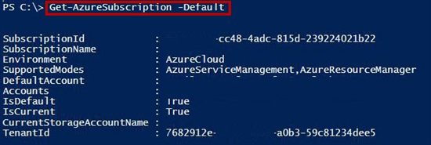](http://social.technet.microsoft.com/wiki/cfs-file.ashx/__key/communityserver-wikis-components-files/00-00-00-00-05/6281.AzurePSWP09.jpg)  
  
**Step 4:** Create New Web App

*New-AzureWebsite PowerShellWebApp01*

[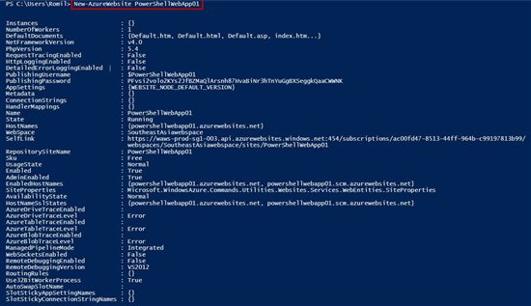](http://social.technet.microsoft.com/wiki/cfs-file.ashx/__key/communityserver-wikis-components-files/00-00-00-00-05/1033.AzurePSWP10.jpg)  
  
There is one problem by default web app will create in the “Southeast Asia” so we need to add location command when we are creating the web app.  
  
  
**Classic Portal**  
  
[http://social.technet.microsoft.com/wiki/resized-image.ashx/__size/550x0/__key/communityserver-wikis-components-files/00-00-00-00-05/4666.AzurePSWP11.jpg](http://social.technet.microsoft.com/wiki/cfs-file.ashx/__key/communityserver-wikis-components-files/00-00-00-00-05/4666.AzurePSWP11.jpg)  
 **Azure Portal**  
  
  
[http://social.technet.microsoft.com/wiki/resized-image.ashx/__size/550x0/__key/communityserver-wikis-components-files/00-00-00-00-05/4265.AzurePSWP12.jpg](http://social.technet.microsoft.com/wiki/cfs-file.ashx/__key/communityserver-wikis-components-files/00-00-00-00-05/4265.AzurePSWP12.jpg)  
**Step 5:**

*New-AzureWebsite PowerShellWebApp01 -Location “West US”*

[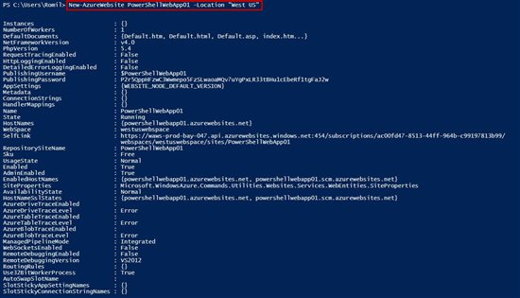](http://social.technet.microsoft.com/wiki/cfs-file.ashx/__key/communityserver-wikis-components-files/00-00-00-00-05/4718.AzurePSWP13.jpg)  
  
**Remove Web App**

*Remove-AzureWebsite -Name WebAppName*

Ex. Remove-AzureWebsite -Name PowerShellWebApp01  
  
  
**Check for Web Apps Name available or not run below command**

*Test-AzureName -Website PowerShellWebApp01*

[http://social.technet.microsoft.com/wiki/resized-image.ashx/__size/550x0/__key/communityserver-wikis-components-files/00-00-00-00-05/4807.AzurePSWP14.jpg](http://social.technet.microsoft.com/wiki/cfs-file.ashx/__key/communityserver-wikis-components-files/00-00-00-00-05/4807.AzurePSWP14.jpg)  
True means this name already used  
  
[http://social.technet.microsoft.com/wiki/resized-image.ashx/__size/550x0/__key/communityserver-wikis-components-files/00-00-00-00-05/4150.AzurePSWP15.jpg](http://social.technet.microsoft.com/wiki/cfs-file.ashx/__key/communityserver-wikis-components-files/00-00-00-00-05/4150.AzurePSWP15.jpg)  
False means this name available for creating new web apps  
  
**Open web app on browser**

*Show-AzureWebsite WebAppNameOnly*

Ex. Show-AzureWebsite PowerShellWebApp01

[http://social.technet.microsoft.com/wiki/resized-image.ashx/__size/550x0/__key/communityserver-wikis-components-files/00-00-00-00-05/4628.AzurePSWP16.jpg](http://social.technet.microsoft.com/wiki/cfs-file.ashx/__key/communityserver-wikis-components-files/00-00-00-00-05/4628.AzurePSWP16.jpg)  
  
  
Congratulations you have learned PowerShell command with Web App on Azure!